
Casper
Software Protection that Works
Casper
User Manual
Software Protection that Works
Casper User Manual

SOFTWARE VERSION: 2.0
Release Date: June 2005
DOCUMENT REVISION nUMBER: 4
© CrypKey (Canada) Inc.
The Devenish Heritage Building
908 - 17th Avenue SW
Suite 200
Calgary, Alberta
T2T 0A3 Canada
Phone 403.258.6274 • Fax 403.264.8838
Sales email Sales@CrypKey.com
Support email Support@CrypKey.com
http://www.CrypKey.com

CrypKey License Agreement

Grant of Rights. In consideration of payment, CrypKey (Canada) Inc. grants to the purchasing company (the “Customer”) the non-exclusive right to possess, use, and make and distribute unlimited copies of the machine-executable code version of the CrypKey Software Licensing System, including all revisions, modifications, and updates thereto furnished to the customer, together with the written User Manuals in relation thereto (collectively the “Software”).
Intended Purpose. The Software is intended to be linked with and incorporated into the product, including, but limited to, the foundation module and installation routines forming a part thereof. No right to distribute the Software on a stand-alone basis is intended by this License Agreement. Any other use of the Software requires written consent from CrypKey. The customer may not reverse engineer, modify, nor create derivative works based on the Software without written consent from CrypKey, except as permitted by acceptable law.
Ownership. All patents, copyrights, and other proprietary rights in the Software are, and shall remain, the exclusive property of CrypKey or its suppliers. The Customer may not assign nor transfer the rights granted in the License Agreement to any person, except the Customer’s subsidiaries and affiliates, without written consent from CrypKey.
Limited Warranty. CrypKey warrants to the Customer that the Software will operate essentially as described in CrypKey brochures and documentation. CrypKey warrants that the media on which the Software is recorded shall be free from defects in materials and workmanship under normal use and service for 60 days from the date of the Customer’s invoice. If failure of the media is a result of accident, abuse, or misapplication of the Software, CrypKey shall not be responsible for its replacement. Applicable law may imply warranties that cannot be excluded or can be excluded only to a limited extent. This Agreement shall be reached and construed subject to such laws.
No Other Warranties. The limited warranty set forth herein is in lieu of, and CrypKey disclaims, any and all other warranties (express or implied) with respect to the software, including any and implied warranty of merchantability or fitness for a particular purpose.
Remedies. Except in connection with a claim for infringement of copyright, patent, or other intellectual property right, the Customer’s sole and exclusive remedy for a breach of warranty shall be: (a) the return of the initial fee paid for the rights granted herein or (b) the correction or replacement of defective software or media. Corrected or replaced Software or media will be warranted to the same extent as the original Software or media for the remainder of the original warranty period or 30 days from the date of receipt by the customer, whichever is longer.
Limitation of Liability. In no event shall CrypKey be liable to the customer for indirect, incidental, special, or consequential damage. In no event shall CrypKey Controls Ltd.’s aggregate liability to the customer exceed the amounts paid to CrypKey by the customer for the software.
The software described in this manual is furnished under a License Agreement and may only be used in accordance with the terms of this agreement.
Microsoft, Windows, Visual Basic, Access, and Windows NT are trademarks of Microsoft Corporation. Watcom is a trademark of Watcom International Corporation. Novell is a registered trademark of Novell, Inc.
Copyright ©1992-2005, CrypKey (Canada) Inc. All rights reserved
Table of Contents
PART 1: SETTING UP CASPER
Chapter 1: Key Points 1
In this Chapter 1
About CrypKey (Canada) Inc. 1
About Casper 1
Issuing Licenses 2
What’s New in Casper 2
How to Use this Book 3
Chapter 2: Technical Help 5
In this Chapter 5
Helpful Notes and Tips for Using CasperWeb 5
System Requirements 6
Casper Functions and Processes 6
Client-Server Architecture 6
Casper Components 6
CasperWeb 7
Client Program 8
Licensing Requests 9
Configuring Casper 9
Generating Site Keys Manually 10
Software Licensing and Authorization 10
Security 12
Firewall Settings 12
Potential Security Breaches 12
Software Updates 12
Anti-Virus Software 12
Issues in Testing 13
CrypKey Contact Information 13
Chapter 3: Getting Started 14
Installing Casper 14
Procedure for Installing Casper 14
Pre-Install 15
Download from the Internet – Initial Steps for Installing Casper 16
CD-ROM – Initial Steps for Installing Casper 19
Installation of Casper – Final Steps 19
Log Files 27
Post-Install 27
Upgrading from Casper version 2.X to current version 28
Pre-Upgrade steps 28
Install Steps for Upgrade 28
Post-Install Steps for Upgrade 29
Testing Casper Upgrade 29
Testing Your Casper Installation 29
Test Local Communications 29
Test Remote Communications 30
Test CasperWeb Database Access 31
Generating Software Licenses 32
Testing Internet-based Authorization Requests and Issuing of Licenses 32
Client Test Program – Internet-based Method 33
Simple Test Program 37
Client Interface Demo – What your Customer Sees 39
Testing Email Authorization Requests and Issuing of Licenses 40
Set up a Test Email Account 41
Sample Test Accounts 41
Test Authorization Requests via Email 47
Automatic Email Authorization Request 47
Manual Email Authorization Request 55
Cancelling the Client Test Program 59
Index 61

List of Tables
Table 2-1: Information Structure 7
Table 2-2: License Communication Options 9
Table 3-1: Procedure for Installing Casper 14
Table 3-2: Procedure for Testing Casper Functionality 40

List of Figures
Figure 2-1: Casper — Software Licensing Process 11
Figure 3-1: Starting Installation from Download 17
Figure 3-2: Installation from Download password 17
Figure 3-3: Installation from Download Temporary file location 18
Figure 3-4: Installation Download – extracting files 18
Figure 3-5: Installation – Main Sequence 20
Figure 3-6: Installation – MS .NET Framework screen 20
Figure 3-7: Installation – MSDE screen 21
Figure 3-8: Installation – MSDE Install progress screen 21
Figure 3-9: Installation – MSDE Install successful screen 21
Figure 3-10: Installation – Casper Server install message 22
Figure 3-11: Preparing to Install message 22
Figure 3-12: Installation – Setup Wizard screen 23
Figure 3-13: Installation – Pre- and Post-Install steps 24
Figure 3-14: Installation – Select Installation Folder 24
Figure 3-15: Installation – Disk Space availability 25
Figure 3-16: Installation – Install in progress screen 25
Figure 3-17: Installation – Administrator password 26
Figure 3-18: Installation Successful screen 26
Figure 3-19: Installation – Post-Install screen 27
Figure 3-20: Successful Local Communications Test 30
Figure 3-21: Successful Remote Communications Test 30
Figure 3-22: CasperWeb Main Menu 31
Figure 3-23: Casper Serial Number Test wizard 33
Figure 3-24: Serial Number test selection 34
Figure 3-25: Serial Number test entry 34
Figure 3-26: Test customer information entry 35
Figure 3-27: E-mail Address Verification window 35
Figure 3-28: Internet Message Processing underway message 36
Figure 3-29: Authorization Request complete 36
Figure 3-30: Client Test Authorization Request successful 37
Figure 3-31: Simple Test Authorization Request successful 38
Figure 3-32: Casper Client demo 39
Figure 3-33: CasperWeb System Maintenance Menu page 1 42
Figure 3-34: System Maintenance Menu page 2 - Email Configuration 43
Figure 3-35: Email Test Page 45
Figure 3-36: Email Support Page 46
Figure 3-37: Casper Client Test Application screen 48
Figure 3-38: Casper Test Application wizard 49
Figure 3-39: Casper serial number mode 50
Figure 3-40: Casper serial number entry screen 51
Figure 3-41: Casper customer information – Casper Wizard 51
Figure 3-42: Casper email verification 52
Figure 3-43: Casper Authorization Request screen 52
Figure 3-44: Authorization request processing message 53
Figure 3-45: Email authorization failure message 53
Figure 3-46: Email access confirmation 53
Figure 3-47: Send Email Confirmation 54
Figure 3-48: Email authorization request sent 54
Figure 3-49: Automated email test successful message 54
Figure 3-50: Automated email test failed message 55
Figure 3-51: Manually send email 56
Figure 3-52: Manual email test set-up: To address 56
Figure 3-53: Manual email test set-up: Subject 57
Figure 3-54: Manual email test set-up: Body 57
Figure 3-55: Manual email test: Customer message 58
Figure 3-56: Manual email test successful message 58
Figure 3-57: Client Test Program cancellation message 59
Figure 3-58: Client Test Program cancellation return value 59

Chapter 1: Key Points
Welcome to Casper, the reliable way to automate the distribution and licensing of your software
C
asper (CrypKey Automated Software Purchase and Electronic Registration) is a software security system designed to enable you, the software manufacturer, to automate and secure the distribution and licensing of your products, and the processing of payments made by your customers.

In this Chapter
In this chapter you will find information on:
- CrypKey Canada Inc.
- Casper, CrypKey’s automated software copy authorization product
- what’s new in Casper
- how to best use the resources of this book
- an overview of issuing licenses for your CrypKey-protected software

About CrypKey (Canada) Inc.
To find out more about CrypKey and our approach to preventing software piracy–one of the most costly and intimidating problems for software developers–visit our web site at www.CrypKey.com.

About Casper
Casper was created to automate the processes of issuing licenses and collecting customer payments. Its main advantages are that it:
- allows users to obtain authorization automatically, which saves on labor and allows payments over the Internet in return for an authorization
- minimizes unauthorized use of software, and
- secures payment for products.
Casper automates the authorization of CrypKey-protected products by verifying serial numbers (Casper eRegister) or by verifying credit card purchases (Casper eCommerce) before authorizing a CrypKey-protected product. See Chapters 5 and 6 for more information on these products.
Important
In order to use the capabilities of Casper, you must have previously purchased either CrypKey Instant or CrypKey SDK.

Issuing Licenses
To provide your customer with a license to use your software product:
- You provide software, protected by CrypKey SDK or CrypKey Instant, to your customer. You can choose to offer your product on a trial basis, either by number of consecutive days used or number of program runs. CrypKey protection restricts your customer’s access to the software.
- When prompted by the Casper Wizard—which you bundled with your software package—the customer sends your Casper Server an authorization request is sent either via the Internet or by email and asks for authorization to use your software. The message includes an encrypted Site Code created by the CrypKey-protected software, based on information extracted from your customer’s computer.
- Casper automatically processes the request.
- If the customer made the authorization request by email, Casper sends a return message containing a software license. The license consists of a Site Key generated by Casper, specifying the type of license restriction that you granted to your customer. The Site Key, which contains the license restrictions that you specify, is a unique key that only your customer can use to run the software on his or her computer. The customer enters the Site Key into the license registration box. If the request was made over the Internet, the authorization is automatic and invisible to the customer, who simply receives a message saying the software is now authorized for use.
See Figure 2-1: Casper — Software Licensing Process in Chapter 2 for an illustrated explanation of the license issuing process.

What’s New in Casper
Casper version 2.0 incorporates a number of new features and enhancements.
The most obvious change is the new CasperWeb, which together with the Casper Wizard provides the full functionality of defining your software products, receiving and processing customer authorization requests, and issuing software licenses. CasperWeb provides a new interface for managing the Casper database (which contains product and customer information), and replaces the Casper Server interface. A new feature available in CasperWeb is System Administration, available through the main menu. Another new feature is eTransfer. eTransfer is offered by CrypKey as a new means of transferring CrypKey licenses from one computer to another over the Internet, anywhere in the world, within seconds. Import file formats have been extended.

How to Use this Book
This book is intended for users familiar with Windows NT/2000/2003/XP. It contains chapters to:
- get you started by installing and testing the product
- use and configure Casper eRegister (authorizes software based on customer-entered Serial Numbers)
- use and configure Casper eCommerce (authorizes software based on credit card transactions)
- understand and configure the Casper Wizard (your customer’s online interface to request a software licenses)
- use eTransfer (to transfer your Casper license up to the Internet, and back to another computer, in seconds)
Note: We recommend that only a systems/network administrator installs and configures your Casper software.
To configure and enable Casper, you will need to read through the sections in this order:
- Part 1: Setting Up Casper – Installing Casper
- Part 1: Setting Up Casper – Testing Casper
- Part 2: Casper eRegister – setting up and enabling Casper’s basic authorization system
- Part 3: Casper eCommerce – setting up and enabling Casper’s credit card transaction system
- Part 4: Casper Wizard – setting up and enabling the Client side Wizard for your customer’s use
- Part 5: Casper eTransfer – how to enable this feature, which allows you to transfer the product license between computers over the Internet
Chapter 2: Technical Help
To use this manual successfully, you require basic information about how Casper software works.
C
asper is a real-time, Internet-based application with a design based on the client-server model. The Casper program resides on your (the software vendor’s) computer. The Client program, which we will call the Casper Wizard, is embedded in the CrypKey-protected application, and is capable of communicating with your Casper Server.

In this Chapter
In this chapter you will find information on:
- system requirements for running Casper
- how the Casper client-server process interacts with your customers
- CasperWeb, Casper’s web-based user interface which manages the database
- the data structure in the Casper database
- the Casper Wizard, your customer’s interface with Casper
- security considerations
- CrypKey technical support and contact information

Helpful Notes and Tips for Using CasperWeb
- CasperWeb is best viewed using Internet Explorer 5.0 (or later). Cookies are not used in the application.
- Some screen pages take several seconds to load. Clicking a button multiple times will not speed up this process, but may in fact confuse the browser. It is best to wait for the page to be fully displayed.
- CasperWeb has many complex screens that display a lot of information. For this reason, a 1024x768 pixel screen was used to develop the pages. Although you can view CasperWeb with a smaller screen resolution, you may have to scroll the window to see all the information contained in the screen page. For correct display of CasperWeb screens, use small font in your Internet Explorer settings.
- By default CasperWeb does not use Hyper Text Transfer Protocol Secure sockets (HTTPS) encryption. However, CasperWeb can be configured manually to use HTTPS after installation.
- CasperWeb and Casper Wizard do use an internal Public Key Encryption to communicate securely with each other.

System Requirements
Casper system requirements include the following:
- Pentium 4® or Intel® Celeron® microprocessor, with 256MB and 100MB of free space on your hard drive
- monitor capable of 1024 X 768 resolution
- mouse
- SMTP/POP3 mail (for email communications)
- Windows NT/2000/2003/XP
- Internet Information Services (IIS) installed (for direct Internet connection)

Casper Functions and Processes
This section gives an overview of the main components of Casper and how the software functions.

Client-Server Architecture
Casper software uses client-server architecture to process your customers’ requests. Casper receives software license requests from your customers via electronic messages transmitted by the Client program (the Casper Wizard).
CrypKey’s software design assumes a standard approach in which Casper is configured to respond automatically to Internet and/or email license requests. For each validated request, Casper generates an authorization Site Key and sends it to the customer as part of an email message, or applies the Site Key automatically if the request is sent via the Internet.

Casper Components
Casper consists of two interdependent components: CasperWeb and the Client. CasperWeb is the Internet-based user interface for maintaining and configuring Casper. The Client contains the Casper Wizard, the customer’s user interface for licensing your product. See below for details.
CasperWeb and database programs reside on your, the software vendor's, computer. The Casper database contains information on products, customers, licenses and customer-specific restrictions. Typically, Casper is configured to reference the database when issuing licenses.

CasperWeb
CasperWeb allows you to maintain the information needed to issue licenses to your customers. These licenses are configured by product codes that relate to serial numbers with individual or common license restrictions. When a user enters a valid serial number or processes a credit card transaction for authorization, they will be issued a license with the restrictions specified in the product code or serial number.
CasperWeb manages the Casper database, which provides the information used by Casper to issue software licenses to your customers. You use CasperWeb to configure product codes, license types, products and product families. You can also manually issue licenses using CasperWeb’s Site Key Generator (more about this in Part 2: Casper eRegister).
CasperWeb performs the following functions:
- configures product families, products, executables, license restrictions, and product codes
- records customer information, including Serial Number, customer name, customer number, product name, license restrictions, and invoice number
- enables you to apply and enforce restrictions on the use of your software
- provides a history of product license authorizations
imports customer, license, and product dataTable 2-1: Information Structure describes the general types of information contained in the Casper database and managed by CasperWeb.
Table 2-1: Information Structure
Data | Family
Family | Category of products. Every product must be a member of a product family.
Product | Product name, description, and version number.
Product Version | Product version identifier.
Executable | Executable name, file name, description, and password.
Executable Version | Executable version identifier.
Options and Levels | Records defining certain features released with executables. Each executable options and levels record refers to an already-defined executable record. To be fully implemented, options and levels must reference features defined in the executable code.
License Type | User-defined license type.
Product Link | Unique association of Family, Product, Product Version, Executable, and Executable Version.
Product Code | Code representing a unique association of relationship of Family, Product, Product Version, Executable, Executable Version, License Type, and price.
Customer Information | Serial Number, customer name, product name, invoice number, and restrictions on the customer’s software use, contact information, address, etc.

Client Program
The Client side of Casper is called the Casper Wizard and runs on your customer’s computer, bundled with the CrypKey-protected software you provide to the customer. The Wizard asks your customer to send a request to Casper for a license to use your software. Casper responds by generating a Site Key.
The Wizard presents a series of windows that guide users through the various available options. The Wizard interface is configurable if you are calling it using CrypKey SDK. If you are using CrypKey Instant, the Wizard is not configurable with e-Register. For the Casper eCommerce option, the Wizard changes to contain the credit card information, product code and price.

Licensing Requests
Casper receives software license requests via either Internet messages transmitted by the Client program or by email messages. Internet messages transmit using the user’s email program or, usually within 15 seconds. Email messages are transmitted using the user’s email program or via SMTP, as quickly as possible. They can be delayed by becoming stored temporarily in various servers along the route to the destination. Internet requests are not configurable; they happen automatically when the request is made. Email requests are checked on an interval that you specify in CasperWeb; the smallest interval you can set is once every minute.
Casper provides three options for communicating licensing information (see Table 2-2: License Communication Options):
- Direct via Internet
- Automatic Email
- Manual Email
Table 2-2: License Communication Options
Option | Description
Direct via Internet | The Casper Client sends authorization requests directly to Casper. Casper processes an authorization request and immediately sends the authorization or an error message to the customer. If the processing is successful, the authorization is automatically entered into the program and the software is enabled.
Automatic Email | The customer sends an email message authorization request to Casper. Casper then processes the information and automatically replies with an email message that contains the authorization. The customer enters the Site Key manually.
Manual Email | The customer sends the authorization request manually via email. Casper then processes the information and automatically replies. This method is used only if a customer has an unusual network configuration that prohibits the automatic send function.

Configuring Casper
In order for Casper to respond automatically to Internet or email messages, you must configure it to acknowledge authorization requests (for details, see Part 2: Casper eRegister).
You can configure Casper for two general types of authorization requests:
- Casper eRegister (Serial Number Authorization): Casper issues a Site Key based on an encrypted Site Code contained in the customer’s message, plus information extracted from CasperWeb. Casper searches the Casper database for a Serial Number, which is included in the customer’s message. Casper compares the Serial Number sent with the authorization request to the information in the database from a previous order. The Serial Number must be included when using CrypKey e-Register.
- Casper eCommerce (credit card authorization): Casper issues a Site Key based on approval of payment by credit card. The approval is obtained through third-party software–if you purchased the Casper eCommerce version of Casper, CrypKey provides PC Charge® as the payment gateway. Casper also supports Payflow Pro®.

Generating Site Keys Manually
Casper automatically generates a Site Key based on a validated request. However, you can generate Site Keys manually using the Site Key Generator. Access the Site Key Generator via the CasperWeb menu at: http://localhost/casperweb/ >Edit Customer Info, enter the Serial Number and click on the Serial Number button, then click on the Site Key Gen button. You would choose this method when your customer communicates a license request via telephone, fax, or regular email, rather than via the Casper Wizard. Or, use the Site Key Generator (a stand-alone Windows program) provided with CrypKey Instant or CrypKey SDK.

Software Licensing and Authorization
See Figure 2-1: Casper — Software Licensing Process for an illustration of the software licensing process.
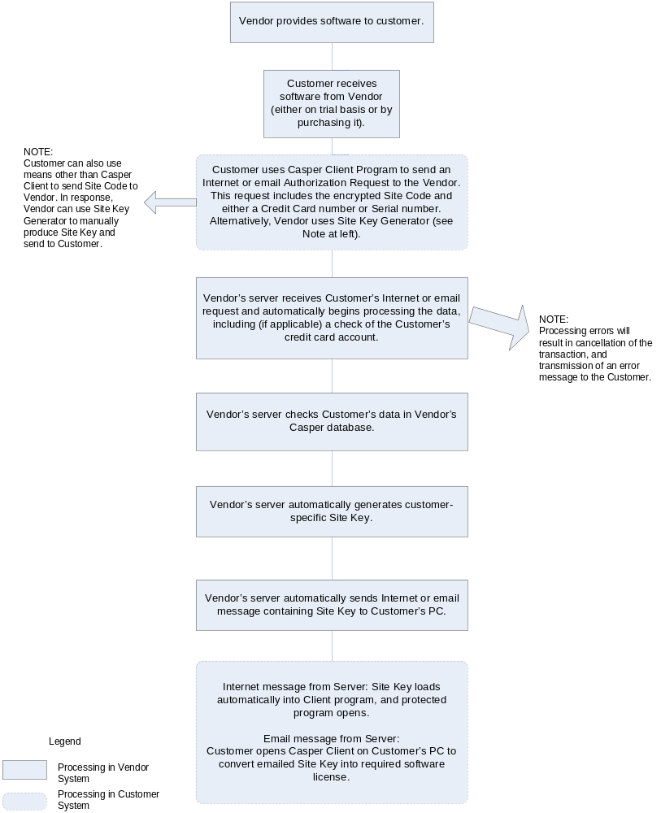
Figure 2-1: Casper — Software Licensing Process

Security
Caution
Since Casper is connected to the Internet, you should ensure the security of your server machine. See the following paragraphs for guidelines.

Firewall Settings
Windows operating system software is prone to attack via network connections. As a result, a software- or hardware-based firewall is needed to control access. In general, the firewall should be set to block all traffic. You should open only a single specific access path for users. For example, if you want users to license their product via the Internet using HTTP (rather than by email using SMTP), then you should open only the incoming port 80.

Potential Security Breaches
Microsoft Windows software is highly network-enabled. Casper uses the Microsoft Data Engine (MSDE) as its database. If you connect your server to the Internet, it is possible for anyone in the world to connect to your server and read or update the data in your database. Since they would require a password in order to have this access, you should pick a nearly impenetrable password – or, better still, use a firewall to block access altogether.

Software Updates
In general, if a software update or upgrade is made available, it should not be installed just for the sake of being updated – unless it is a security patch, as discussed in the next paragraph. When you make a change to the system, an incompatibility issue or other problem can result.
Note: For every update that you make to the operating system, you must completely retest all functions of Casper to ensure that it still operates correctly.
Microsoft Windows software often has security flaws that allow people to breach the security of your server. For this reason, when Microsoft releases a patch or update it is usually advisable to install it. For updates to other software, the install should be performed only if it addresses a specific problem or adds a specific required feature.

Anti-Virus Software
Any Windows server should have anti-virus software from a reputable vendor installed and active on the system. Full system scans should be scheduled regularly (ideally, daily) to protect the system. Even the most heavily-protected systems have virus infection risks. The risk is significantly reduced if the server system is used only as a server and not for other tasks, such as browsing the Internet.
Note: Ensure that your anti-virus software updates itself automatically with the latest virus definitions.

Issues in Testing
You should not use the Casper server for testing software under development, since changes may result that cause an incompatibility. As well, testing of CrypKey-protected software should not be conducted on the Casper server. Some installations cause the wrong version of the NT driver to be installed, or other undesirable results to occur. The Casper server consists of a complex group of applications that can be damaged by any security system changes that a new driver may introduce.
An Internet server is very sensitive to change, and often an entire rebuild is the fastest or only way to fix a problem caused by changes made by other software. In order to minimize risk of business interruption and loss of time, we recommend you dedicate the machine to running only the Casper server, and relentlessly disallow any other sotware to run on it.

CrypKey Contact Information
CrypKey (Canada) Inc.
Mailing Address: CrypKey (Canada) Inc.
The Devenish Heritage Building
908 - 17th Avenue SW
Suite 200
Calgary, Alberta
T2T 0A3 Canada
Phone: 1-403-258-6274
Fax Line: 1-403-264-8838
Support email Support@CrypKey.com
Sales email Sales@CrypKey.com
Website http://www.CrypKey.com
Chapter 3: Getting Started
CrypKey offers a streamlined procedure for installing Casper either by downloading from the Internet or from a CD.
I
n this chapter you will find step-by-step instructions on how to:
- install or upgrade Casper
- test Casper (with test data)

Installing Casper
This section pertains to the initial installation of Casper. For directions on upgrading your current version to the latest version, see Upgrading from Casper version 2.X to current version below. You can install Casper in either of two ways:
- By downloading the installation files from the CrypKey website (www.CrypKey.com, select Support>Download). You must you must have a valid Casper support contract or have purchased within the last 60 days.
- From a CD provided by CrypKey (Canada) Inc.
Note: If you are using a CD to install Casper, you should check the CrypKey website to ensure that you have the most recent version. The most recently released version is always on the site at www.CrypKey.com, Support>Download.

Procedure for Installing Casper
Follow the steps in Table 3-1: Procedure for Installing Casper to successfully install Casper.

Table 3-1: Procedure for Installing Casper
This step | is in this section . . .
1. Complete the Pre-Install | Pre-Install
2. Install Casper using either of these options:  (a) Download and install from Internet  OR  (b) Install from supplied CD | (a) Download from the Internet – Initial Steps for Installing Casper  OR  (b) CD-ROM – Initial Steps for Installing Casper
3. Complete the Casper installation – this applies to both the Internet and CD-ROM option | Installation of Casper – Final Steps
4. Complete the Post-install | Post-Install
5. Test the installation | Testing Your Casper Installation
Pre-Install. Before installing, you must prepare your system to receive and manage these files. This preparation work is called the Pre-Install, and is described in the section Pre-Install below.
Post-Install. Some tasks need to be completed after the installation. This is called the Post-Install, and is described both below in the section Post-Install and in the file Casper Install Steps.rtf, which comes with the product and is displayed during the install process. Always check the Casper Install Steps.rtf file, as it contains the latest instructions for your version.
Latest Installation Instructions
The installation process often undergoes changes and enhancements from a previous version. The install instructions for your version of Casper are included with the software in the file Casper Install Steps.rtf. You can also download the current version’s installation file and instructions from http://www.crypkey.com/download.asp. For any further queries, please contact CrypKey support.
Warning
Casper installs a new instance of SQL Server. If you have any existing instances of SQL Server, you will need to back up all pre-existing databases. We suggest installing Casper on a computer that has no existing instances of SQL Server.

Pre-Install
Procedure
Before installing Casper, please ensure that:
- IIS (Internet Information Services) is installed. If not, install it, using the default settings. (To install IIS, select Add/Remove Programs, select Add/Remove Windows Components. For Windows 2000/XP select IIS. For Windows 2003, select Application Server, click Details, make sure Application Server Console and ASP.NET are checked.)
Note: .NET Framework must be installed after IIS or Casper will not run. .NET Framework will be installed by the Casper installation program if you do not already have it on your computer. If you’ve already installed .NET Framework, you can simply uninstall it, and then install IIS. .NET Framework will be reinstalled by the Casper installation program.
- For new installations: You may have to delete the directory C:\Program Files\Microsoft SQL Server if you had Microsoft SQL Server installed in the past.
- The installer must use an administrator account.
IMPORTANT
Do not install via a Terminal Services session.

Download from the Internet – Initial Steps for Installing Casper
Procedure
- Download Casper from the Internet and store it in a convenient place, such as your desktop. The latest version is available from the download page at http://www.CrypKey.com/download.asp.
- From the Downloads page, click on “here” (the upgrade link).
- Enter the user name and password supplied when you purchased the product. Click OK. The Registered Users Downloads page is displayed. If you cannot get access to the Downloads page, please contact CrypKey support at Support@CrypKey.com.
- Scroll down and choose the latest version of Casper for download. Download time will vary according to the speed of you Internet connection.
- Save the downloaded executable to a convenient location such as your desktop.
- Run the executable. The InstallShield Wizard is displayed (see Figure 3-1: Starting Installation from Download).
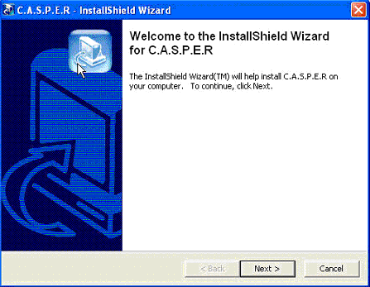
Click Next to proceed or Cancel to abort the install.
Figure 3-1: Starting Installation from Download
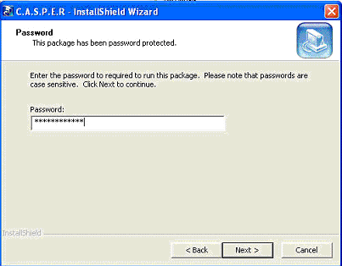
Enter the password to unwrap the Casper installation files. The password is case-sensitive (use all caps). To obtain the password, contact CrypKey Support at Support@CrypKey.com.
Figure 3-2: Installation from Download password
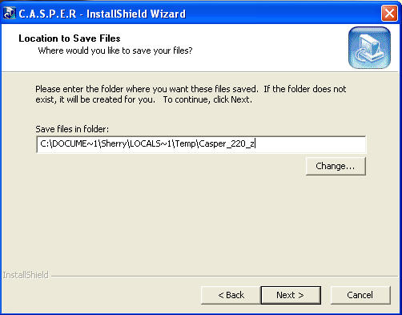
Specify a directory name, rather than using the default directory (e.g. add a letter to the end of the directory path).
Figure 3-3: Installation from Download Temporary file location
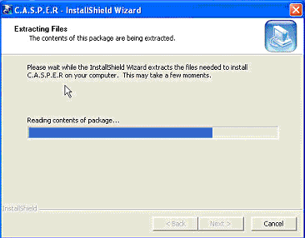
Click the Next button. The system will launch the sequence of windows discussed in Installation of Casper – Final Steps to complete your installation.
Figure 3-4: Installation Download – extracting files

CD-ROM – Initial Steps for Installing Casper
Procedure
This procedure is intended for users who are installing Casper from a CD-ROM.
Note: The following steps replace the initial installation steps described above in Download from the Internet – Initial Steps. Once the CD-ROM install is complete, go to the section Installation of Casper – Final Steps.
- Insert the CrypKey CD-ROM. The CD should automatically run. If it does not, double-click the CrypKey.exe program on your CD-ROM drive.
- The Welcome to CrypKey screen displays. It includes several functions that you can explore to obtain information about Casper and other CrypKey products. Use the install button to install Casper.
- Click the install button. The CrypKey Install screen displays, with options for the different CrypKey products.
- Click the install CrypKey CASPER button. The system launches the sequence of screens discussed in the next section, Installation of Casper – Final Steps.

Installation of Casper – Final Steps
Ensure all pre-install steps are done before proceeding.
The different components that will be installed are:
- MSDE (Microsoft Desktop Engine) for SQL support
- Microsoft .NET Framework
- MDAC (Microsoft Data Access Components) 2.8
Procedure
- In the installation sequence, follow the prompts as shown in the screens below.
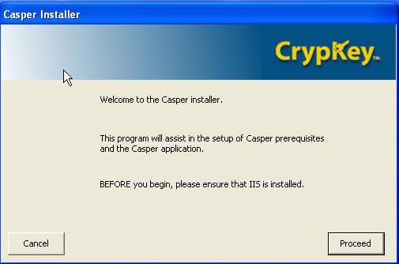
Click Proceed.
Figure 3-5: Installation – Main Sequence

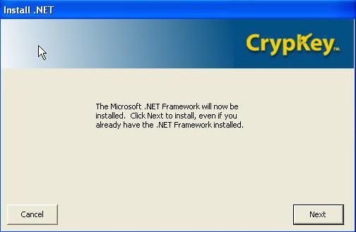
Click Next.
Figure 3-6: Installation – MS .NET Framework screen
- Install Microsoft .NET Framework at this point, even if it was previously installed.
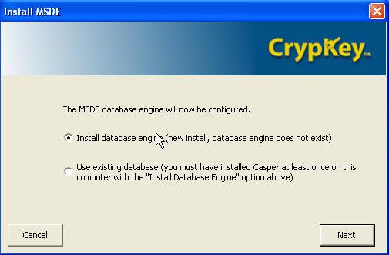
Select Install database engine (new install, database engine does not exist)
Click Next.
Figure 3-7: Installation – MSDE screen
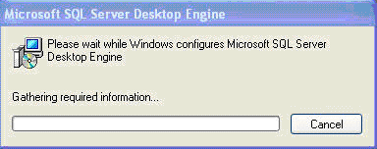
Figure 3-8: Installation – MSDE Install progress screen
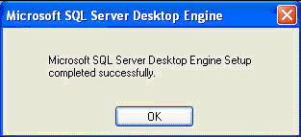
Click OK.
Figure 3-9: Installation – MSDE Install successful screen

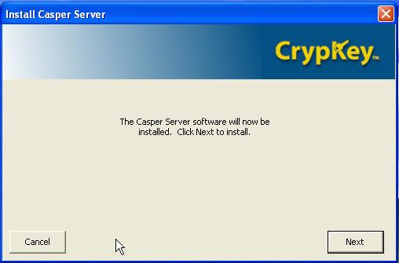
Click Next.
Note this process make take a few moments, during which you will see the Preparing to Install screen (see the following screen).
Figure 3-10: Installation – Casper Server install message

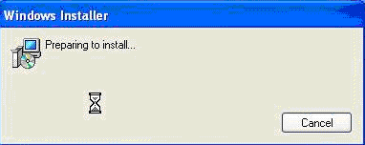
Click Cancel to abort the install.
Figure 3-11: Preparing to Install message

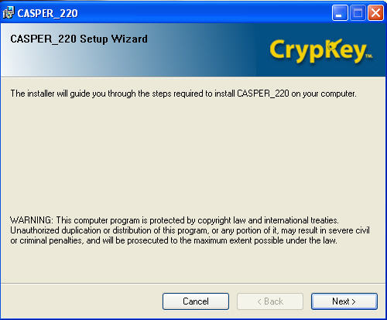
Click Next.
Figure 3-12: Installation – Setup Wizard screen
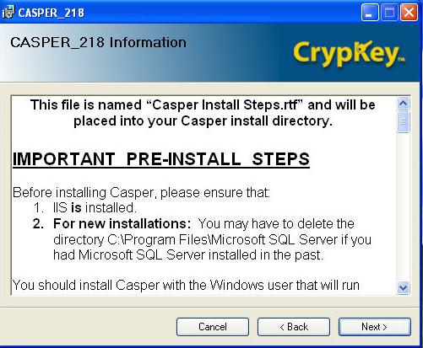
Click Next.
The Casper Install Steps.rtf document is displayed. These instructions will be correct for the version you are installing.
Figure 3-13: Installation – Pre- and Post-Install steps
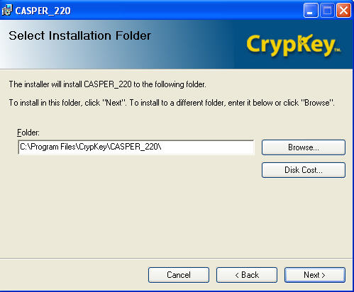
Save Casper to a directory. We recommend accepting the default directory -- this will be the permanent location for the files.
Click Next.
To select a different directory, click Browse.
To view the space available on each drive on your computer, click Disk Cost. (See the Disk Space figure below.)
Figure 3-14: Installation – Select Installation Folder
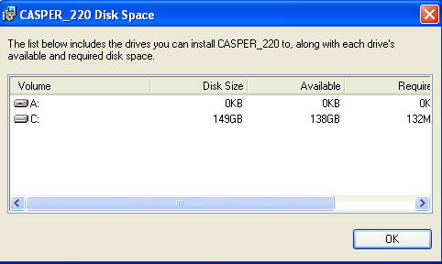
Figure 3-15: Installation – Disk Space availability

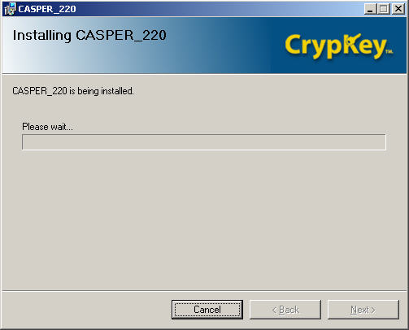
This screen is a sample only. The most current version of Casper will be installed.
Figure 3-16: Installation – Install in progress screen

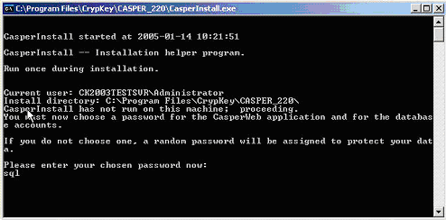
Enter the password. The default password is sql. If you choose a different password, take care to remember it as it will be the administrator password. Press Enter on your keyboard to complete the install.
Figure 3-17: Installation – Administrator password

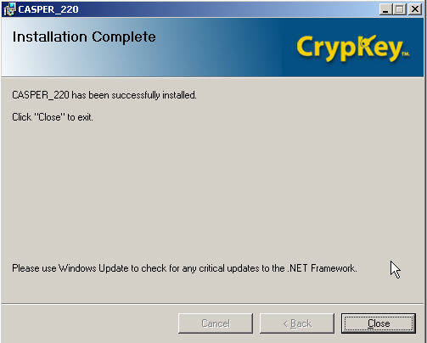
Casper returns a successful installation message. Click Close.
Figure 3-18: Installation Successful screen
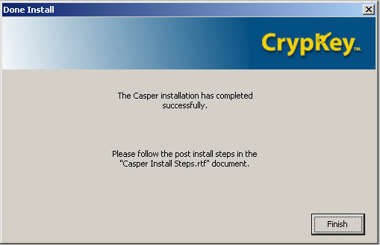
Click Finish.
Casper reminds you to run the Post-Install steps (see Post-Install section below).
Figure 3-19: Installation – Post-Install screen

Log Files
During the installation, your system will create three log files and place them on your C: drive: Casperinstall.log, CasperSetupDb.log, and CasperSetupAsp.log. You can use these files, or send them to CrypKey Technical Support to help troubleshoot problems with your installation.

Post-Install
Important
After installing Casper, follow the instructions for the post-install in CasperInstallSteps.rtf. The post-install also instructs you on how to authorize your Casper software.
Note: Casper Install Steps.rtf is available in the installation folder you selected for Casper in Figure 3-14: Installation – Select Installation Folder, or by selecting Start menu>Programs>Casper.

Upgrading from Casper version 2.X to current version

Pre-Upgrade steps
Procedure
These steps are for upgrading your system from version 2.X to the current version.
- Create a backup of your database. Make a backup of the files casper_data.mdf and casper_log.ldf files in the SQL Server install directory. This is typically the directory c:\Program Files\Microsoft SQL Server\MSSQL\Data.
- Make a backup of the sk32mmtd.dll file, which is found in the Casper install directory.
- Make a backup of the pub.key and priv.key files from the Casper install directory.
- Note: The skmmtd32.dll, pub.key and priv.key files are company-specific files that CrypKey provided to you when you purchased the Casper product. The pub.key file may exist only on the Client software side.
On all systems: If possible, uninstall any instances of SQL Server prior to installing Casper. As part of uninstalling SQL Server, delete the directories \Program Files\MSSQL7 and \Program Files\Microsoft SQL Server.
Note: For some versions of Casper, the installation of SQL Server and Casper are tightly coupled. Uninstall Casper to simultaneously uninstall SQL Server.
- Stop the CrypKey License Service. To do this, go to the DOS prompt and type: net stop “crypkey license”.
- Follow the install and post-install steps for upgrading from these versions to the latest version (see the sections below).

Install Steps for Upgrade
Procedure
- Follow the instructions for new installs in the section above, Download from the Internet – Initial Steps for Installing Casper, or CD-ROM – Initial Steps for Installing Casper, as applicable.
- Follow the steps above in Installation of Casper – Final Steps.

Post-Install Steps for Upgrade
Procedure
- Follow the post-install steps for a new install as outlined in the Casper Install Steps.rtf file for the version you are installing.
Note: Casper Install Steps.rtf is available in the installation folder you selected for Casper in Figure 3-14: Installation – Select Installation Folder, or by selecting Start menu>Programs>Casper/Casper Install Steps.rtf.

Testing Casper Upgrade
Follow the instructions in the section below for authorizing and testing the Casper installation.

Testing Your Casper Installation
After installing Casper, you must perform tests to verify that the Server, Client and database are operating correctly.
The strategy for testing your Casper installation is straightforward:
- Verify that your local browser can communicate with the Server (see Test Local Communications below);
- Verify that a browser on a remote computer can communicate with the Server (see Test Remote Communications below);
- Verify that CasperWeb has access to the Casper database (see Test CasperWeb Database Access below; and
- Test Internet-based and email-based authorization requests and issuing of licenses (see Testing Email Authorization Requests and Issuing of Licenses below).

Test Local Communications
Procedure
From the local browser on your machine, type in the following URL:
http://localhost/casper/InternetServer.dll?ping&test
If your local communication is operating, the system displays the following window:
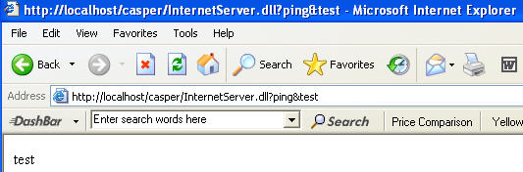
Figure 3-20: Successful Local Communications Test
If the above window does not appear with the value specified in the URL (in this case, “test”), there is a problem with your configuration. Please contact CrypKey Technical Support.

Test Remote Communications
Procedure
From a browser on a remote system, type in the following URL:
http://pcname/casper/InternetServer.dll?ping&test
where pcname is replaced by the name of the computer where Casper is installed.
If your remote communication is operating, the system displays the following window:
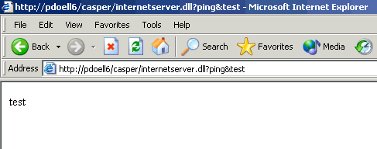
Figure 3-21: Successful Remote Communications Test

Test CasperWeb Database Access
Procedure
- To test CasperWeb’s access to the Casper database, open a browser and type:
http://pcname/CasperWeb
- or -
http://localhost/CasperWeb
where pcname is replaced by the name of the computer on which Casper is installed, and the value localhost is for local test.
Log in to CasperWeb as instructed above in the Post-Install section.
- The system will display the Main Menu (see Figure 3-22: CasperWeb Main Menu below).
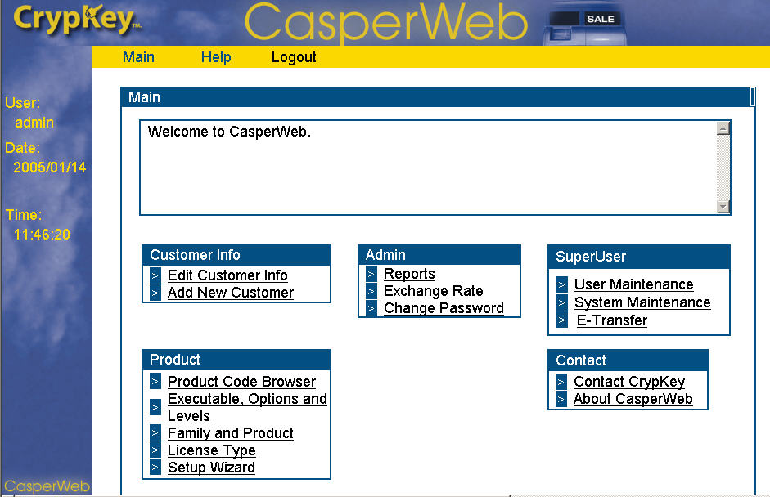
Figure 3-22: CasperWeb Main Menu
- To test access to database information, click on a link (e.g. Product Code Browser) and view the test product code supplied by CrypKey.
- You are now finished testing the Casper installation.

Generating Software Licenses
You can configure Casper to generate software licenses (in response to your customers’ requests from the Casper Wizard) in two ways:
- Serial Number: Generates licenses based on customer record information stored in the Casper database. This component of Casper, Casper eRegister, uses the customer’s assigned Serial Number to verify the request is valid.
Note: Vendors create their own serial numbers, which they provide to their customers at point of sale.
- Casper eCommerce: Generates licenses based on approval of payment using the customer’s credit card number through third-party software.
For instructions on how to configure Casper to use either of the above methods―using the online user interface CasperWeb―see Part 2: Casper eRegister, and Part 3: Casper eCommerce, respectively.

Testing Internet-based Authorization Requests and Issuing of Licenses
First, you will test the system’s default method of processing requests, via the Internet. The tests below use Serial Numbers to process the authorization request of CrypKey-protected products—the customer is given a prepaid serial number to use when they wish to have their software authorized for their own use. The other option is to enable credit card transactions (see Part 3: Casper eCommerce for details on authorizing software purchase transactions using credit cards).
Note: For these initial tests, you will use default data supplied with Casper. In Part 2: Casper eRegister, you will enter your company-specific product information and customer serial numbers and run tests using your own data. We strongly recommend that you run the test below before using live data.
In the procedures below, CrypKey has supplied a test product and test serial number.
There are two methods of testing Internet communications (both use Serial Number processing):
- Run the Client Test Program (see Client Test Program below)—this test offers more flexibility than the Simple Test; or
- Run the Simple Test Program (a simplified version of the same test program). See Simple Test Program below.

Client Test Program – Internet-based Method
Procedure
- Display the Casper Client Test Application window (Start menu>Programs> Casper>Client Programs>Client Test Program) (see Figure 3-37: Casper Client Test Application below).
- Enter the following information:
  - a valid Product Code (use the default, TESTING, the test product code included with Casper)
  - your Casper URL (this is the URL for the server on which Casper is installed; typically this is http://localhost/casper).
Note: The Site Code is automatically populated for you.
- Click the Run button. The system prepares to send an Internet message and displays the following screen:
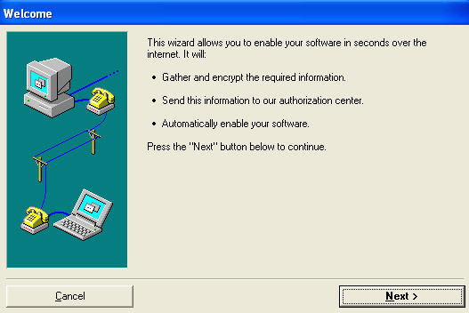
Click Next.
Figure 3-23: Casper Serial Number Test wizard
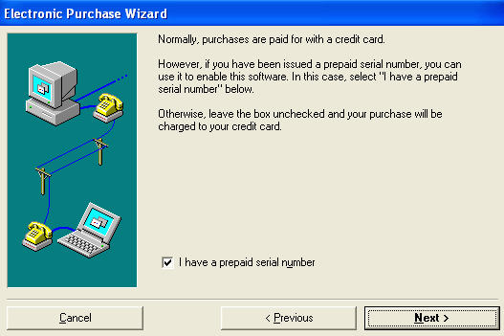
Check the Serial Number box. This is how Casper will verify the software authorization request.
Click Next.
Figure 3-24: Serial Number test selection
Note: Be sure the I have a prepaid serial number box is checked.
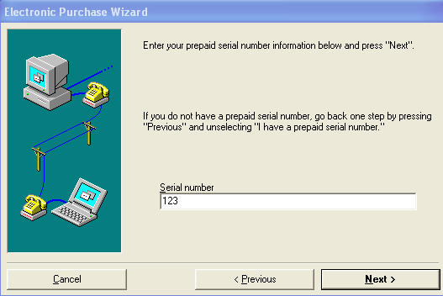
Click Next.
Enter 123, the Serial Number supplied for testing.
Figure 3-25: Serial Number test entry
Note: Be sure you enter 123, the test serial number included with Casper.
- The information for the customer information screen below does not have to be authentic, but the email address you enter should be your own email account, which represents the customer’s email address.
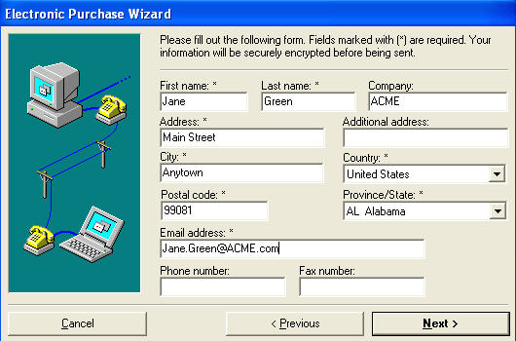
Click Next.
Figure 3-26: Test customer information entry
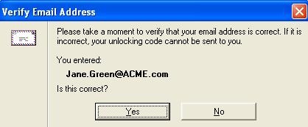
Verify the email address and click Yes.
Figure 3-27: E-mail Address Verification window
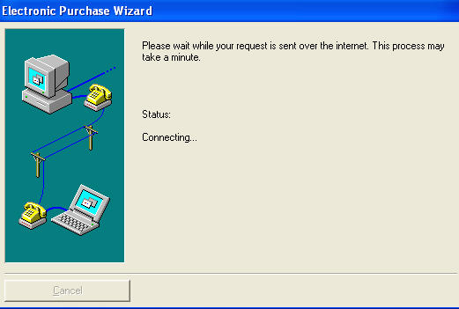
Figure 3-28: Internet Message Processing underway message
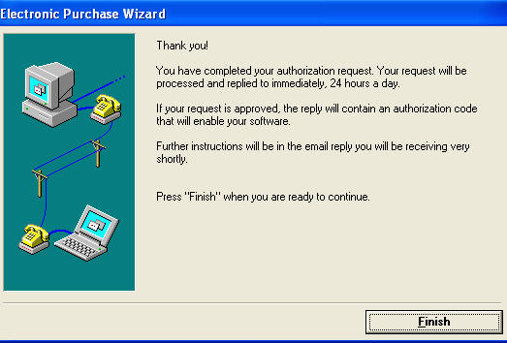
Click Finish.
Figure 3-29: Authorization Request complete

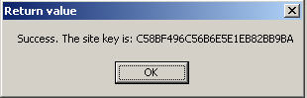
Click OK. This message informs you that the test Client was able to send an authorization request, and Casper was able to receive it and send back an authorization via HTTP.
Figure 3-30: Client Test Authorization Request successful
The message above informs you that the Internet authorization request was successful. The test Client was able to send an authorization request, and the Server was able to process and receive the request.
Note: If the above message popup does not appear, there is a problem with your communications. Please contact CrypKey Technical Support.
Note: Your customer will not see the site key message when they use Casper to authorize your software. Authorization is invisible and automatic. The customer will only receive a message that the software is authorized.

Simple Test Program
Instead of running the Client Test Program above, you can use the simplified “Simple Test Program” to test Casper quickly. If you run the Simple Test Program on your Casper server, do not modify any of the entry fields and press the Send button to test. The result should look similar to Figure 3-31: Simple Test Authorization Request successful.
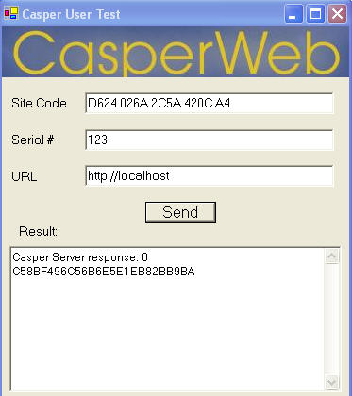
Figure 3-31: Simple Test Authorization Request successful
Procedure
- Display the Casper Test Application window (Start menu>Programs> Casper>Client Programs>Casper Simple Test Program).
- Enter the serial number 123.
- Enter your Casper URL.
- Click Send. Casper should return a response value of “0”, indicating the test was successful. It also shows that the Server was able to receive and process your authorization request.
Note: If the return value of “0” does not appear, there is a problem with your installation. Please contact CrypKey Technical Support.

Client Interface Demo – What your Customer Sees
Now that you have conducted a successful test of the software registration request over the Internet, you can run a demo program to simulate what your customer will see when making an authorization request. This demo program uses the serial number verification method. The credit card demo program is shown in Part 3: Casper eCommerce. To run the Casper eRegister test:
- Go to the CrypKey web site at http://www.CrypKey.com/downloaderegister.asp and click on CrypKey Casper Demonstration Download here, OR
run the demo program from the Start menu>Casper>Client Programs>Casper Client Demo.
- If you downloaded the demo program, save the program to your desktop or other convenient location.
- Unzip the file and install example.exe.
- Run the program (double click on the executable). The Casper Demo window appears (see Figure 3-32: Casper Client demo).
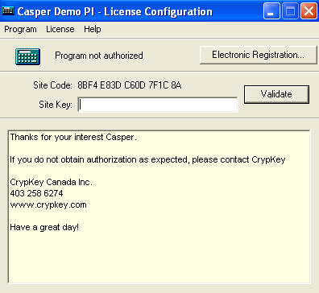
Figure 3-32: Casper Client demo
- Click the Electronic Registration button.
- Follow the screens and enter the prepaid serial number 123.This example captures customer information and stores it in the Casper database. This prepaid serial number is valid for a 3 day authorization. By default, the demo uses the HTTP for requests. If that is not available, Casper defaults to email requests.
- If the Site Key is sent by email, enter it into the Site Key field in the Casper Demo window.
- Click Validate. A message pop-up appears informing the customer that their copy is authorized.
See Part 4: Casper Wizard for more information on how your customers use the Client side of Casper to send you a request for authorization to use your CrypKey-protected software. Instructions for enabling Casper and configuring the Wizard are included, for both CrypKey Instant and CrypKey SDK, depending on which product you use to protect your software.

Testing Email Authorization Requests and Issuing of Licenses
After you have tested Casper’s ability to process requests via the Internet, you are ready to test authorization of software requests by email. You will need to test the ability of Casper to process software authorization requests via email if you plan to offer this option to your customers. Be sure to configure a test email account and then run the tests as shown in Table 3-2: Procedure for Testing Casper Functionality
Casper supports only POP3 and SMTP email protocols.
Note: The following email authorization requests test the serial number processing capability of Casper eRegister. (Credit card transactions are discussed in Part 3: Casper eCommerce).
Table 3-2: Procedure for Testing Casper Functionality
This step | is in this section . . .
1. Set up email account | Set up a Test Email Account
2. Test customer authorization using automated email | Test Authorization Requests using automated email: Automatic Email Authorization Request
3. Test customer authorization requests using manual email | Test Authorization Requests via Email: Manual Email Authorization Request
4. Run a demo program of Casper eRegister’s Casper Wizard to simulate what your customer will see from the Client side. | Client Interface

Set up a Test Email Account
Before you can run the email authorization tests, you must configure CasperWeb for the email account, and then test the account to establish that Casper is correctly communicating with the email server.

Sample Test Accounts
You will use your own test accounts and server address for these tests. The sample data shown in the figures below represents these demo accounts:
Vendor account email address: testemail@myserver.com
URL: mail.myserver.com
logon user: Systems Admin
Customer account: email address: Jane_Green@ACME.com
customer name: Jane Green
Caution
The email configurations you set in the CasperWeb pages, as shown below, directly impact how Casper processes software authorization requests by email. Take care to choose the settings according to how you want Casper to process associated email.
- Open CasperWeb and log in: (see CasperInstallSteps.rtf in the Casper installation folder, or selecting Start menu>Programs>Casper).
- From the Main page, click on the System Maintenance link. Page 1 of the System Maintenance screens appears (see Figure 3-33: CasperWeb System Maintenance Menu below).
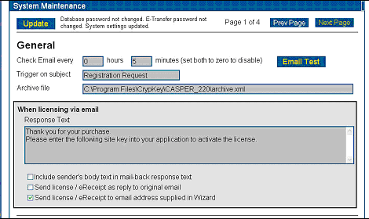
Figure 3-33: CasperWeb System Maintenance Menu page 1
- Check Email every fields: in the General section of the page, enter how often (in hours and minutes) you want Casper to check email from your customers. The Casper Client sends email registration requests to the server whenever an HTTP request is unable to be processed. Later, on page 2 of the System Maintenance screen you will set up the email account to be used for this purpose (see Figure 3-35: Email Test Page below).
- Trigger on subject field: acts as a filter for messages. Only emails with the specified subject in the subject line (e.g. “Registration Request” will be processed by Casper.
- Response text field: Enter the response message to be sent to your customers when licensing your software via email. In your message, be sure to instruct your customer to enter the site key that Casper generates and sends with the reply email, to complete the authorization.
Click the checkbox options that you require. Typically you should select the checkbox Send license/eReceipt to email address supplied in Wizard. If you select this checkbox, Casper will send the reply email to both the Server and the customer’s email address as entered in the Casper Wizard. If this option is not selected, the reply is sent to the originating email address.
- Click Update to save your changes.
- Click Next Page to go to page 2 of the System Maintenance menu. The Email Configuration screen is displayed (see Figure 3-34: System Maintenance Menu page 2 - Email Configuration below).
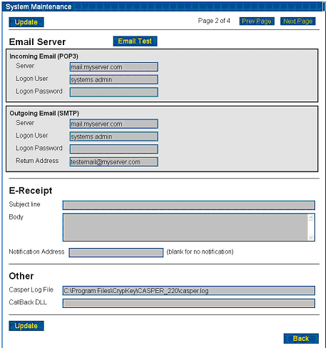
Figure 3-34: System Maintenance Menu page 2 - Email Configuration
- Incoming Email, Outgoing Email: enter the name(s) of the Server that handles incoming and outgoing email; the Logon User (either your user name or email address, depending on how the email server is set up); the Logon Password; and the Return Address to which customers may reply. This should be an email address that is checked by a human, such as a support group’s email address, and is usually different from the Casper server email address. Click Update to save the changes.
Note: The return email address must be filled in. Some email servers require it.
Note: The incoming email server logon user and the outgoing email server logon user may be different.
E-Receipt Subject line field: this section pertains to credit card transactions, but can also be used to send you notification that Casper recognized the serial number processing transaction. If the reply is an eReceipt, it goes to the customer as well. For information on how to configure E-Receipts for credit card transactions made via the Internet, see Part 3: Casper eCommerce, in this manual.
- Under the Other section, the Casper Log File location is set by default. This is a log of all the Casper events which can be used for troubleshooting.
Call Back DLL: Callback information is optional and not required to test email.
- Click Update. The email configuration is finished.
- Click Email Test. The Email Test screen is displayed (see Figure 3-35: Email Test Page).
- You will need to run three tests to ensure the email server and Casper can communicate: Send (a test message from Casper to the email server); Read (the test email retrieved by Casper); and Process (processes the software registration request you sent).
These tests will confirm that the overall process is functional:
- the email server receives the email from the Client program, which calls the Casper Wizard
- Casper retrieves the Client email from the email server
- Casper generates a Site Key and mails it to the user (via email server)

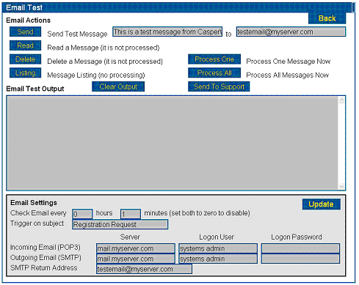
Figure 3-35: Email Test Page
- Send test: In the Send Test Message line, enter the Casper server email address you are using to test the system. Click Send.
- Scroll down in the Email Test Output area to view the message confirming the test email was sent successfully. This means CasperWeb was able to send email to the email server.
Note: If you have trouble interpreting the output, copy and paste the output in an email message and send to CrypKey support.
- View the test email account to see if the message from the Casper server was delivered.
Note: Make sure the email in the incoming Inbox is not set to mark email as read upon delivery, or Casper will not be able to detect the registration request.
- Read test: Click Read. Scroll down in the Email Test Output area to view the message confirming the test email was received and read by Casper successfully.
Tip: You can click the Clear Output button after each test to clear the message area.
- Other function buttons and fields on this page:
Delete: deletes one message from the Casper email account.
Listing: Lists all unprocessed messages in Casper email inbox and numbers the emails consecutively.
Clear Output: Clears the data in the Email Test Output area.
Email Test Output: message area for emails sent, read or processed
Process One: Processes the first message in the Casper email inbox.
Process All: Processes all messages in the Casper email inbox.
Send to Support: displays the following page (see Figure 3-36: Email Support Page), where you can fill out contact information and send a message to CrypKey support. The data in the Email Test Output area on the previous page is automatically copied to the Data area.
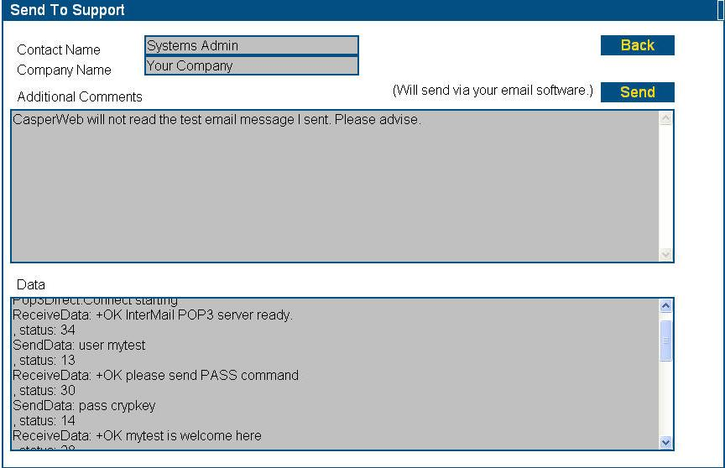
Figure 3-36: Email Support Page
- The information you entered in the Email Support page is copied to your email program and addressed to CrypKey support.
- At this point you have run the Send and Read tests. Click Process to process the first email in the Casper inbox. If the test email you sent contains valid customer information (encrypted site Key), CasperWeb will return a “successfully processed” message in the Email Output Area.
- If the Process test is not successful, send a message to CrypKey support using the Send to Support page.

Test Authorization Requests via Email
You can test authorization requests sent by your customers to use your software with the Client Test Program (Start menu>Programs>Casper>Client Programs>Client Test Program). The following tests use email-based messaging.
Note: Throughout these tests, note any errors and contact CrypKey Technical Support if required. You can also perform some troubleshooting by analyzing the casper.log file. Please include the casper.log file in correspondence with CrypKey support so that we can use it for analysis as well.
You will run two tests:
- Automated email communication—this is an alternative method your customer can use to send you software license authorization requests (see Automatic Email Authorization Request below).
- Manual email communication (see Manual Email Authorization Request below).

Automatic Email Authorization Request
Using the server-side Client Test Program (see Client Test Program – Internet-based Method), you will process an authorization request sent from the Casper Wizard on your customer’s side, to your Casper server via email.
Note: This test uses a serial number to verify the request. For information on how to test serial number requests using the Internet-based method instead of email, see the subsection Testing Internet-based Authorization Requests and Issuing of Licenses.
Procedure
- Double-click the Client Test Program (CaspTest.exe) in the \Client directory.
- or -
Select Start>Programs>Casper>Client Programs>Client Test Program
- The Casper Client Test Application screen appears. Type in an invalid URL in the format:
http://pcname/casper/
where pcname is replaced by the name of the computer on which the Client software is installed.
Note: If testing e-mail the URL must be invalid or the HTTP transaction will work.
- The Casper Client Test Application screen appears, similar to the example below:
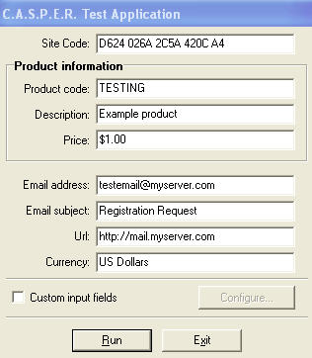
Click Run.
Enter required information (see the following step)
Figure 3-37: Casper Client Test Application screen
- In the Casper Test Application Window, the Site Code, Product Information, Email subject and Currency are all filled in by default.
Email address: Enter the test email account Casper will access to process the authorization request. This is the address from which the email registration request will be sent. This should be the same email address you specified in CasperWeb when setting up the email account (see Figure 3-33: CasperWeb System Maintenance Menu page 1).
URL: Enter an invalid URL (to force Casper to use email rather than Internet messaging.
Click Next.
Figure 3-38: Casper Test Application wizard

Click Next.
Check Serial Number box.
Figure 3-39: Casper serial number mode
- This information for the customer information screen below does not have to be authentic, but the email address you enter should be your own test email account, which represents the customer’s email address. If you selected the Send license/eReceipt to email address supplied in Wizard option (see Figure 3-33: CasperWeb System Maintenance Menu page 1), the Site Key will be sent to this address. If you did not select this option, the reply email containing with the Site Key will be sent to the originating email address.
Enter Serial Number.
Click Next.
Figure 3-40: Casper serial number entry screen
Click Next.
Figure 3-41: Casper customer information – Casper Wizard

Verify the email address and click Yes.
Figure 3-42: Casper email verification
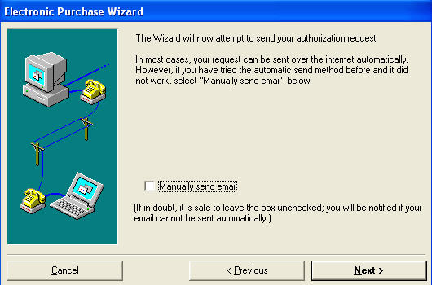
Click Next.
The system prepares to send an Internet message – but as you entered an invalid URL, it will fail.
Figure 3-43: Casper Authorization Request screen
Figure 3-44: Authorization request processing message
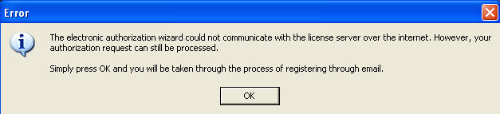
Casper offers the option of using email.

Click OK.
Figure 3-45: Email authorization failure message
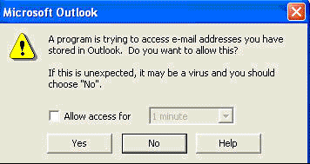
You may receive confirmation messages similar to these. Allow the email program to send an email by clicking Yes.
Figure 3-46: Email access confirmation

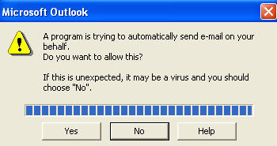
Figure 3-47: Send Email Confirmation
Click Finish.
Figure 3-48: Email authorization request sent
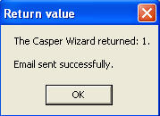
This message reports the email was sent successfully.

Click OK.
Figure 3-49: Automated email test successful message
If the message above does not appear, there is a problem with your configuration. Please contact CrypKey Technical Support.
The message above tells you that the email communication worked, meaning that the test Client was able to send an authorization request.
The process is:
- Casper sends an encrypted registration request email to the Casper email account (specified in the Client Test Application window, see Figure 3-37: Casper Client Test Application ).
- Casper then processes the received email.
- Casper sends another email containing the Site Key to the customer email account you specified in the customer information window (see Figure 3-41: Casper customer information).
- The customer will then copy and pastes the Site Key into the CrypKey-protected software to authorize it. To view a simulation of what the customer sees on the Client side, refer to the Client Interface paragraph below.
If your attempt to verify authorization requests by automatic email fails, you will see the error message in Figure 3-21: Successful Remote Communications Test. In this case you would use the manual email authorization request test. We advise you to try the manual email authorization test to ensure it is working correctly.
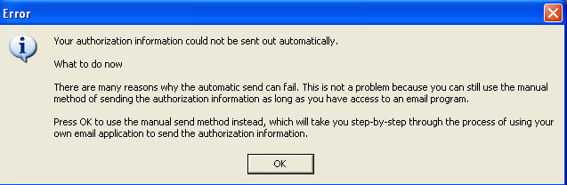
Figure 3-50: Automated email test failed message

Manual Email Authorization Request
This is another method of requesting license authorization if there is a problem with an automated email request.
Procedure
- In the Casper Test Application window, enter an invalid URL in order to force the system to use email rather than Internet messaging.
- Click the Run button and follow the instructions on the screens as in the Automatic Email Authorization Request section above.
- The system displays the Casper Authorization screen as shown in Figure 3-51: Manually send email.
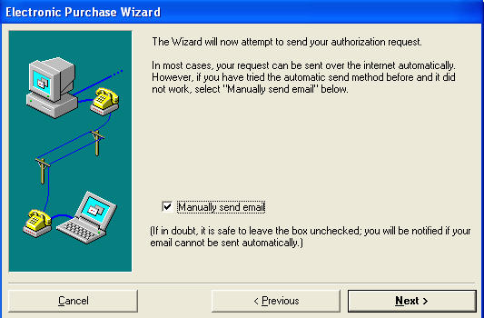
Click Next.
Figure 3-51: Manually send email

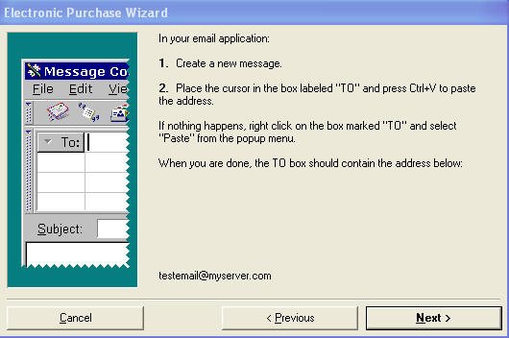
Follow the on-screen instructions to create a test email To address.

Click Next.
Figure 3-52: Manual email test set-up: To address
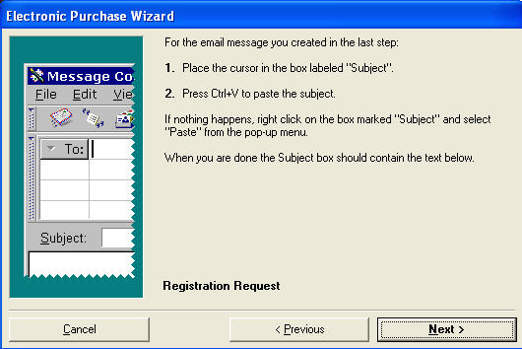
Follow the on-screen instructions to create a test email Subject.

Click Next.
Figure 3-53: Manual email test set-up: Subject

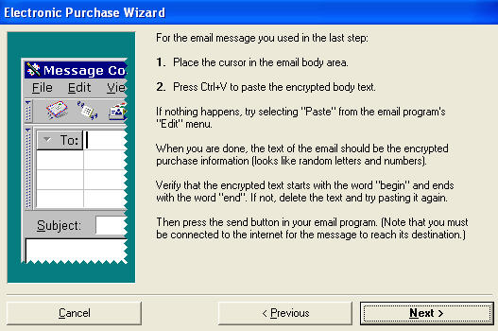
Follow the on-screen instructions to create a test email Body.
Click Next.
Figure 3-54: Manual email test set-up: Body
This is what your customer would see when receiving confirmation of a successful authorization request via the Casper Wizard.
Click Next.
Figure 3-55: Manual email test: Customer message

This message reports the email was sent successfully.

Click OK.
Figure 3-56: Manual email test successful message
If the message above does not appear, there is a problem with your configuration. Please contact CrypKey Technical Support.
The message tells you that the manual email communication worked, meaning that the test Client was able to send an authorization request. The process is:
- Casper sends an encrypted registration request email to the Casper email account (specified in the Client Test Application window, see Figure 3-37: Casper Client Test Application ).
- Casper then processes this email and sends an email containing the Site Key to the customer email account you specified in the customer information window (see Figure 3-41: Casper customer information).
- The customer then copy and pastes the Site Key into their CrypKey-protected software to authorize it.

Cancelling the Client Test Program
To cancel the Client Test Program from any screen:
- Click the Cancel button. The following pop-up message appears:
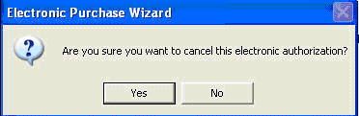
Click Yes.
The Client Test Program returns to the main menu.
Figure 3-57: Client Test Program cancellation message
- Click Yes. and another pop-up message is displayed:
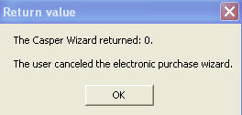
Click OK.

Figure 3-58: Client Test Program cancellation return value
Index
This index includes page references for significant occurrences of Casper topics and terms in this manual.

anti-virus software 12
authorization requests 8
types of 10
Casper
configuration options 10
eCommerce 10
features 1
install options 14
new features 2
system requirements 6
Test Application Window 49
URL 33
Casper Client 5, 8
Casper database 7
Casper eRegister
serial number authorization 10
CasperWeb
and Casper database 7
functions 7
information structure 7
Site Key Generator 7
tips for using 5
Client See Casper Client
CrypKey
Instant 2
SDK 2
CrypKey Business Contact information 13
Customer
email address 50
database 7
downloading Casper 16
Electronic Purchase Wizard See also Wizard, Client
enabling Server to generate Site Key 10
email account
for testing 49
firewall 12
information structure 7
install
terminal services session warning 16
installation
log files 27
of Casper 14
installing Casper
from CD 19
from download 16
license
issuing procedure 2
requests from customers 9
license authorization
credit card type 10
serial number type 10
license requests 6
licensing
your product 6
log files (installation) 27
MDAC install 19
messages
email 6
Internet 6
Microsoft NET Framework install 19
MSDE 12
install 19
Payflow Pro 10
PC Charge 10
post-install 15
database upgrade 29
pre-install 15
database upgrade 28
general 15
security considerations 12
anti-virus software 12
firewall settings 12
Microsoft Windows 12
software updates 12
Site Code 2
automatic population 33
encrypted 10
Site Key 2, 10
generated by Server 10
generated manually using CasperWeb 10
software licensing process 11
software updates 12
SQL server 15
system requirements 6
terminal services session
install warning 16
Test Application Window
for Casper 49
testing
automated email 49
Casper 14
Casper installation 29
email account 49
issues 13
local communications 29
manual email 55
remote communications 30
serial number processing 32
third-party software
credit card authorization 10
trial software 2
Wizard
Electronic Purchase 5, 8
See also Client 8
InstallShield 16

